**Information System Management Lab**

**BCOM 307**

**Assignment #6**

***Submitted by:***

**Name:** YASH JAIN

**Enrollment No:** 03914788818

**Semester:** B.Com(H) 5th Semester

**Class:** B.COM(H)

**Section:** B.Com 5A

**Date of Submission:** 25/09/2021

***Submitted to:***

**Praveen Kumar Singh**

**Assistant Professor, MAIMS**



**Department of Commerce**

**Maharaja Agrasen Institute of Management Studies**

**Affiliated to Guru Gobind Singh Indraprastha University, Delhi**

**Sector -22, Rohini, Delhi -110086, India; www.maims.ac.in**

Maharaja Agrasen Institute of Management Studies

Affiliated to GGS IP University; Recognized u/s 2(f) of UGC Recognized by Bar Council ofIndia; ISO 9001: 2015

Certified Institution Sector 22, Rohini, Delhi -110086, India; [www.maims.ac.in](http://www.maims.ac.in/)

Department of Commerce

Academic Year: 2020-21

Semester: Vth

# Assignment No.6

# Unit No:

**Course/Subject Code:** BCOM 307 **Subject Title: Information System Management Lab**

# Issue Date: Last Date of Submission:

**Instructions for Students:**

# All Questions are Compulsory.

1. The student should attach proper cover page for each assignment clearly mentioning the Assignment No.
2. Each assignment should be prepared by the student individually with proper explaination and screenshots.
3. A4 size ruled sheets should be used for the assignment.
4. Assignment pages should be serially numbered at the bottom of page.

***During online education mode, upload scanned copy of the complete assignment including cover page latest by due date.***

|  |  |  |
| --- | --- | --- |
| **Question No.** | **Question** | **CO No.** |
| 1 | Create a table called ‘Person’ that contains four columns : PersonID, LastName, FirstName, and Age, and create another table ‘Orders’ with columns - OrderID, OrderNumber and PersonID.   |  |  |  |  | | --- | --- | --- | --- | | **Person ID (Primary Key)** | **LastName**  **(Not Null)** | **FirstName (Not Null)** | **Age**  **(Not Null)** | | 1 | Hansen | Ola | 30 | | 2 | Svendson | Tove | 23 | | 3 | Petterson | Karl | 20 |  |  |  |  | | --- | --- | --- | | **Order ID (Primary Key)** | **Order Number (Not Null)** | **Person ID**  **(Foreign Key)** | | 1 | 77895 | 3 | | 2 | 44678 | 3 | | 3 | 22456 | 2 | | 4 | 24562 | 1 | | **CO1** |
| 2 | Insert values in ‘Order’ table with personID = 4.  **CO 1** |
| 3 | Delete from table ‘Orders’ where personID = 1; |
| 4 | Delete from table ‘Persons’ where personID = 1; |

**ASSIGNMENT 6 - FOREIGN KEY CONSTRAINT**

**Task 1 : Create a table called ‘Person’ that contains four columns : PersonID, LastName, FirstName, and Age, and create another table ‘Orders’ with columns - OrderID, OrderNumber and PersonID.**

|  |  |  |  |
| --- | --- | --- | --- |
| **Person ID (Primary Key)** | **LastName**  **(Not Null)** | **FirstName (Not Null)** | **Age**  **(Not Null)** |
| 1 | Hansen | Ola | 30 |
| 2 | Svendson | Tove | 23 |
| 3 | Petterson | Karl | 20 |

|  |  |  |
| --- | --- | --- |
| **Order ID (Primary Key)** | **Order Number (Not Null)** | **Person ID**  **(Foreign Key)** |
| 1 | 77895 | 3 |
| 2 | 44678 | 3 |
| 3 | 22456 | 2 |
| 4 | 24562 | 1 |

The following task is completed using the **‘create table’** command, along with the **‘primary key’** constraint, the **‘not null’** constraintand the **‘foreign key’** constraint. The ‘Not Null’ constraint, when put on a column within a table definition, tells us that the values of that column cannot be left empty while inputing values.The syntax for not null constraint (to be used in table definition) is:

column_name datatype not null,

Foreign Key represents relationship between tables. A foreign key is a column (or a group of columns) whose values are derived from the primary key / unique key of some other table. The syntax for foreign key (to be used in creating table after all the columns are defined) is:

foreign key (column name from foreign table) references primary-table-name(primary key of primary table),

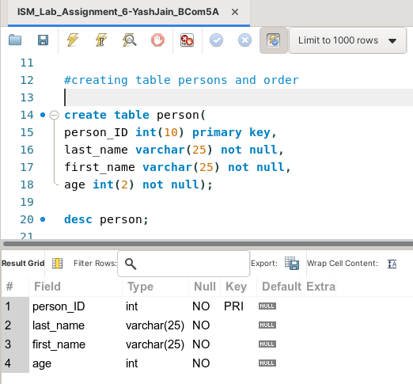

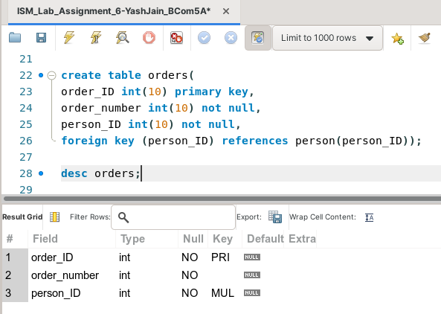

Now, to insert the given values in the tables, we will use the **‘insert into’** command.

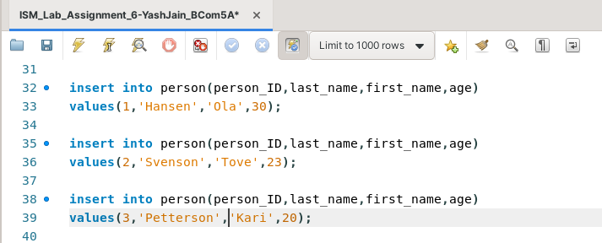

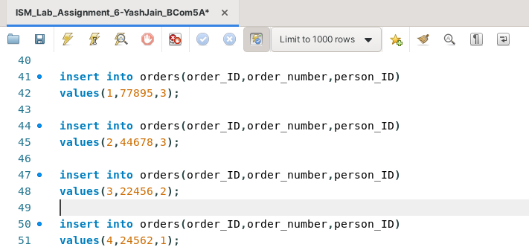

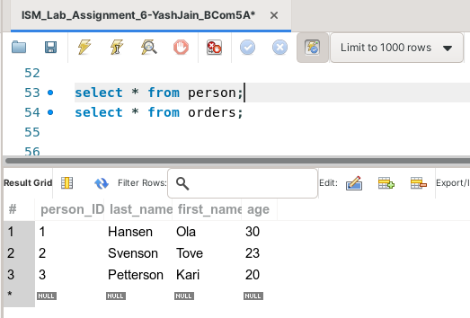

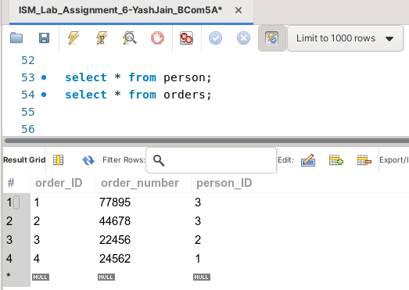

**Task 2: Insert values in ‘Order’ table with personID = 4.**

The given task can be completed using the **‘insert into’** command. Note that when you will enter values, **it will show an error**, ‘Foreign key constraint fails’. This is because the ‘personID’ column is a foreign key linked to the column with the same name in the table ‘Person’. Hence, it will only accept the values present in the personID of the ‘person’ table.

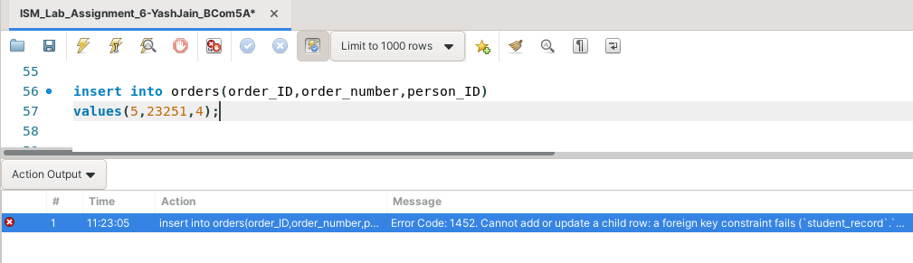

**Task 3: Delete from table ‘Orders’ where personID = 1;**

This task can be completed by using the command **‘delete’**. However, **if we try to delete the record from the table ‘persons’ first, then we won’t be able to do it. It will show an error, ‘Foreign key constraint fails’.**

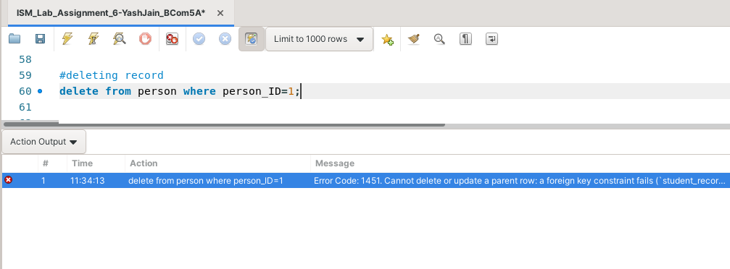

This is because since both the tables are linked via the foreign key column, hence **first we have to delete that record from the foreign table, only then we will be able to delete it from the primary table**. This is depicted below.

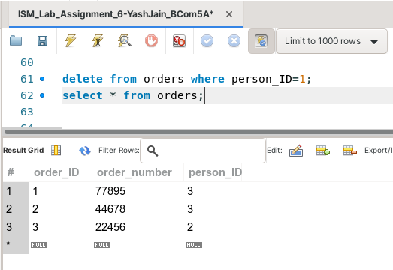

**Task 4: Delete from table ‘Persons’ where personID = 1;**

This task can be completed using the **‘delete’** command. Now, since the record is already deleted from the foreign table, we will be able to delete it from the primary table as well.

